Leigh Cummings
Yuke Han
Kennedy Rodriguez
STAT 406/605
Mary Gray
Is Food A Problem? Introduction
Background:
Food insecurity is the lack of consistent access to sufficient, affordable, nutritious food. It can be spurred by a combination of factors such as geographical, socio-economic, legislative, and others that create barriers like a lack of grocery stores per capita, social inequality in the types of food accessible to the masses, price accessibility, and even transportation barriers. Food insecurity is a major public health concern. It can lead to an increased risk of chronic health conditions, including diabetes, obesity, and heart disease. Specifically in DC, the research shows that families with children, seniors (age 65+), and Latinx and black households face increased levels of food insecurity.
Our project focused on understanding the factors associated with food insecurity in Washington, DC. Food insecurity is a complex issue influenced by economic conditions, transportation access, geographic location, and the availability of affordable food options. Understanding which factors are most closely related to food insecurity can help both community members and policymakers better address local needs. Our target population consisted of DC residents aged 16 and older. Because transportation and affordability are frequently cited as barriers to food access, we designed our survey around these themes. We hypothesized that distance to grocery stores and an individual's purchasing power would help explain whether obtaining food is perceived as a problem. Logistic regression was then used to examine these relationships and answer our central research question: Is Food a Problem?

Methodology

Survey Design
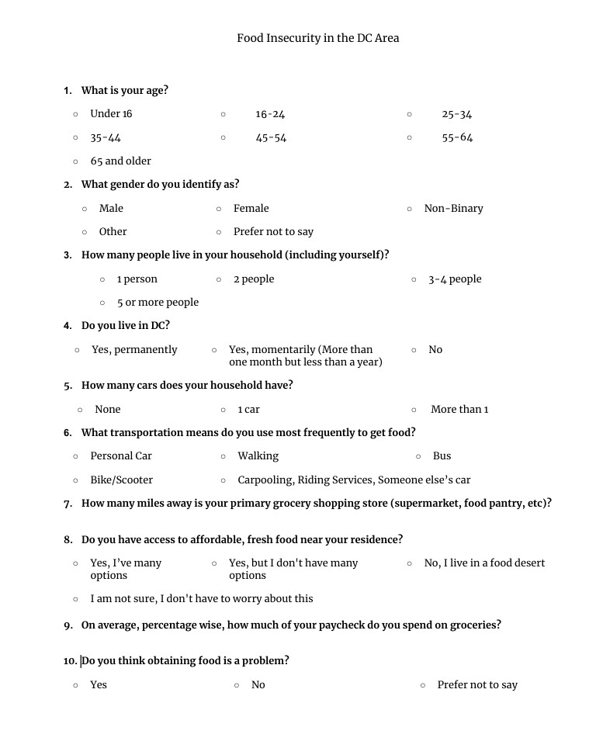

Our survey consisted of 10 questions that we believed would help us better understand food insecurity in Washington, DC. While every question was related to the topic, some ultimately provided more useful information than others. We began with demographic questions such as age, gender, and household size to explore whether certain groups appeared more vulnerable to food insecurity. Household size was of particular interest because the resources needed to feed a larger household may differ substantially from those needed to support an individual. Additional questions focused on transportation and accessibility, including vehicle ownership, distance to grocery stores, and primary transportation methods. Finally, we included affordability-related questions, such as the percentage of income spent on groceries, and concluded with our primary research question regarding whether obtaining food is perceived as a problem.
First, we had our demographic questions: age, gender, and household size. Our hope for these questions was to investigate if any group was most vulnerable to food insecurity; household size also has a tangible relationship with affordability, since the income that feeds one person might not be enough to feed a family. Then we have question 4, which, like question 1, helps us determine if the observation is a valid observation (16+ year old, DC resident). Questions 5 to 7 make inquiries on the transportation capabilities of the respondent – or so to say, Will having a car reduce food insecurity? Will the distance have an impact on their perception of food accessibility? Do they have other accessible means of transport? Then question 8 and 9 inquiries on their affordability means, where we choose to ask the percentage of their income spent on food instead of the actual amount due to concerns of social desirability bias (people will try to show off their wealth) and also for consideration of the fact that the amount spent of groceries might not have the same impact on two different respondents ($100 of grocery might mean nothing to a father of two but be acceptable for a college student). Then, finally, question 10 is our research question.
While crafting the questions, we wished to be as direct as possible while softening down the questions to avoid non-response on potentially intrusive questions, such as the percentage of income used on groceries. We tried to ask neutral questions while combining both open-ended and closed-ended questions to capture quantitative and qualitative data. We piloted our questions with 16 real respondents and got their feedback. Before this, we had 15 questions. We also attended sessions with an experienced librarian at Bender Library.

Clustering Stage One
Given our interest in investigating the effects of distance and affordability as explanations for whether obtaining food was a problem, we utilized these as traits for clustering the DC area. The reason why we chose clustering over SRS or stratified was due to its practicality of not requiring too detailed information on the population (like in stratified) while maintaining some representation of the geographically spread population of DC –which SRS would not allow with its equal chance for all. It also gave in to our time constraints.
We obtained a GeoJSON and a data set by the ACS called ACS 5-Year Economic Characteristics DC Census Tract, which divided the DC area into 206 unique regions, which we identified as clusters. We decided to cluster these 206 observations based on mean income. Using the elbow method for K-means clustering, we found that less than 10 was optimal for clustering, so from there we chose five. Unlike in most clustering, where one gets to choose one cluster, due to our clusters being separated based on income, using SRS, we choose one cluster above the true median and one below. We called these two clusters cluster 2 and 5, which had a population of 16 years and up of 76,994 and 175,127, respectively (556,781 total for the DC area). Based on the populations of the selected clusters, the recommended sample sizes were 182 respondents for Cluster 2 and 331 respondents for Cluster 5. Although these targets were larger than what could reasonably be achieved within the project's time frame, they provided a useful benchmark for evaluating the representativeness of our final sample and guided our data collection efforts.
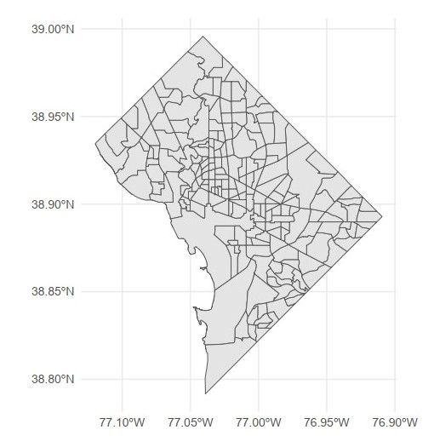
ACS’ DC’s 206 Unique Regions

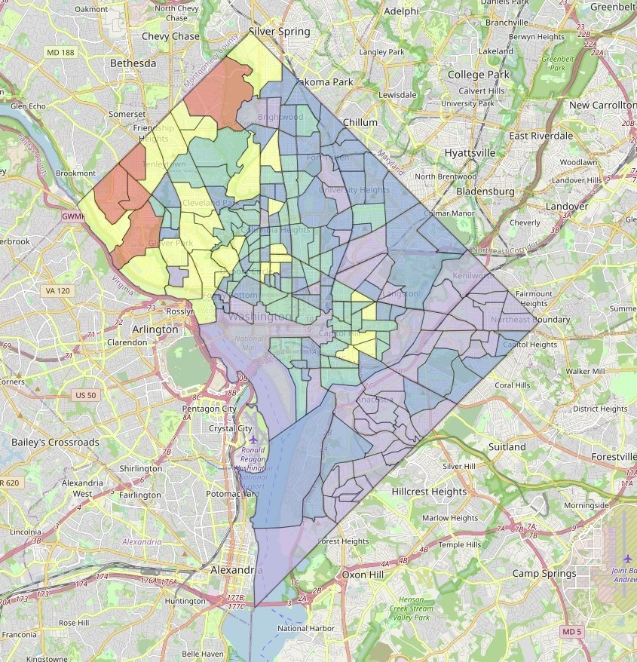 | 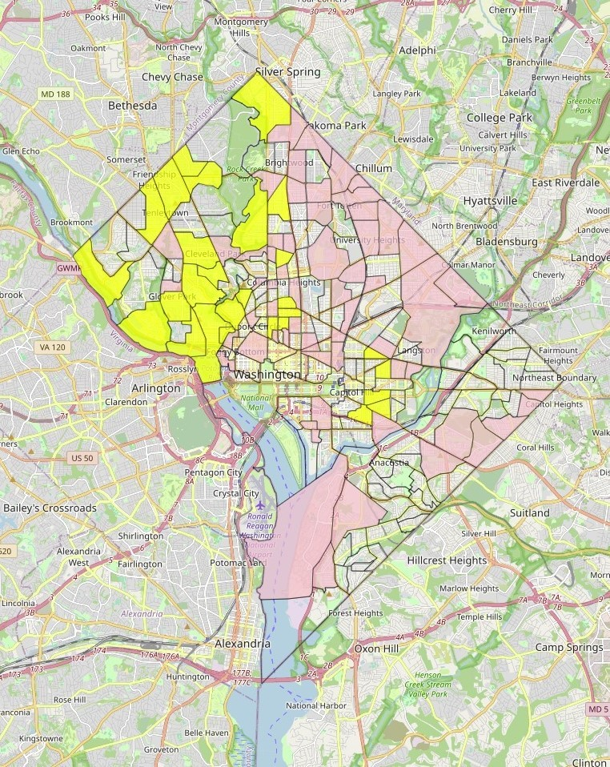
Five Cluster Areas in DC Based on Mean Income | Clusters 2 (yellow) and five (pink)
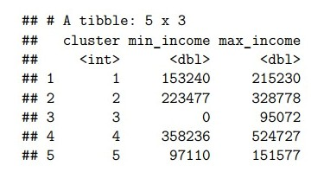 | 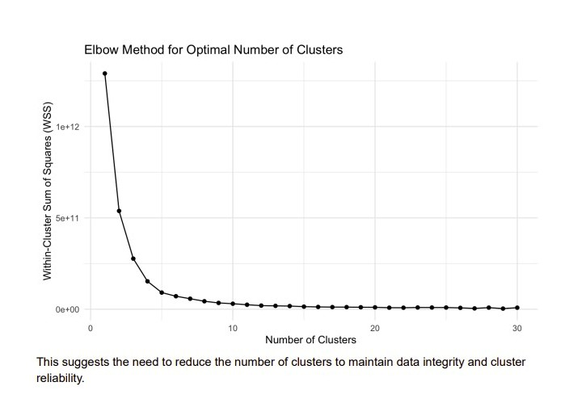
Median Income ranges per cluster. | Elbow Method for Optimal Cluster
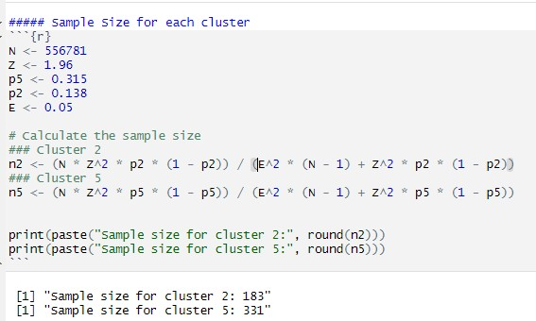
Sample Sizes for cluster 2 and 5.

Clustering Stage Two
After the first stage clustering, we performed a second stage clustering based on DC bus routes to choose our sampling locations (bus stops). From a GeoJSON and data set in Open Data DC called Metro Bus Lines, we mapped and identified which bus lines passed through our clusters (147); from those, we chose 10 per cluster through SRS. We chose 10 since we thought it was a practical baseline to ensure adequate representation without oversampling smaller clusters. Based on the number of bus stops in each cluster, we got a sample size of bus stops to go to for each (first stage) cluster, which was 14 for cluster 5 and 10 for cluster 2. After the final SRS, we got 24 locations to survey.
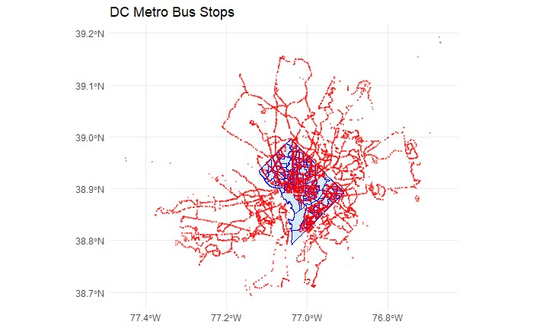 | 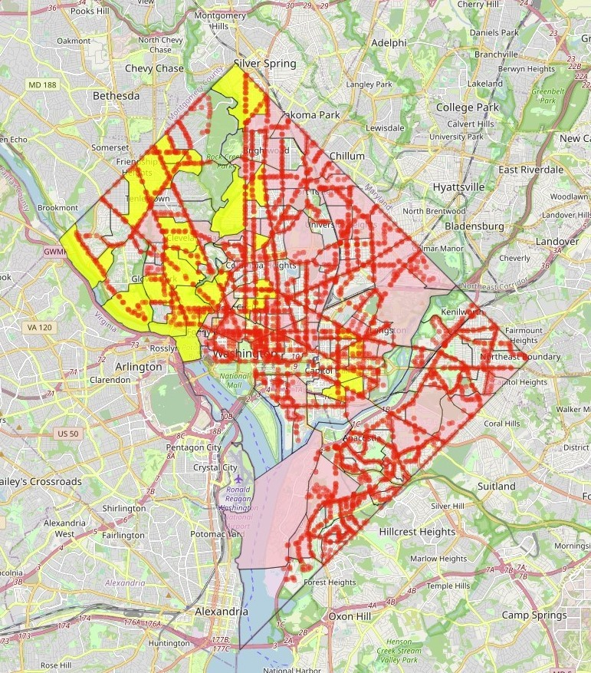
Open Data DC’s Metro Bus Lines GeoJSON | Metro Lines that pass through our clusters

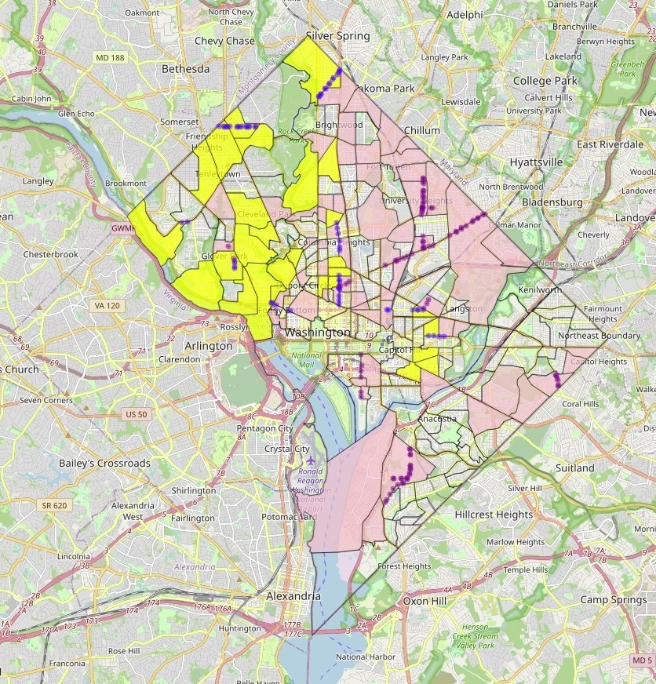 | 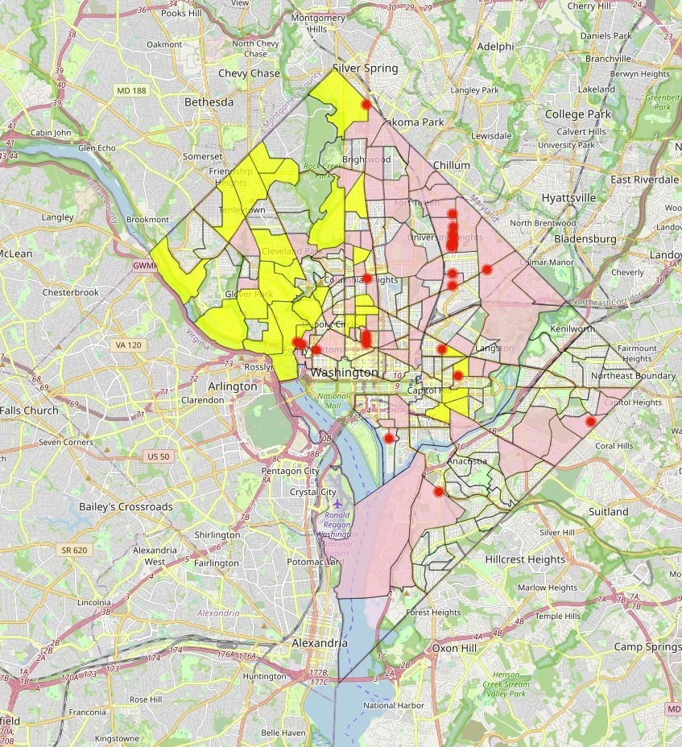
20 Sampled Bus Routes for Cluster Two and Five | 24 bus Stops Chosen
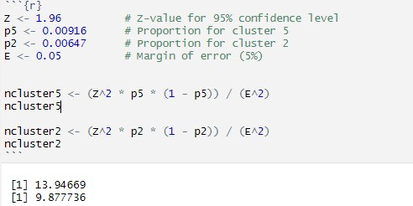
Sample size for each second-stage cluster

Data Collection:
The 24 selected locations were divided among the three group members, with each location assigned a target of approximately three to four respondents. To improve diversity within the sample, data collection was conducted at different times of day and on different days of the week. Participants were approached only if they appeared to meet the study requirements and were willing to participate. While we attempted to obtain a broad range of respondents, younger individuals appeared more likely to participate, which may have influenced the final age distribution of the sample.
We also faced a few limitations. Some days the weather was very cold, around 30-40°, which affected the prevalence of people outside as well as people willing to stop and talk in the first place. Due to the high winds and low temperatures, people often only arrived at the bus stop when they were sure the bus was coming. In the same vein, daylight saving time resulted in it becoming dark around 4:30-5:00 pm; thus, people were less likely to be outside and/or want to talk. This also limited the scope of time in which we could conduct our survey. Lastly, some locations generally had low foot traffic, which negatively affected our goal of surveying 4-5 people per location.
As a result, we ended up collecting 103 responses, originally close to the desired response ratio of 35% for cluster 2 and 65% for Cluster 5.

Raw data summary
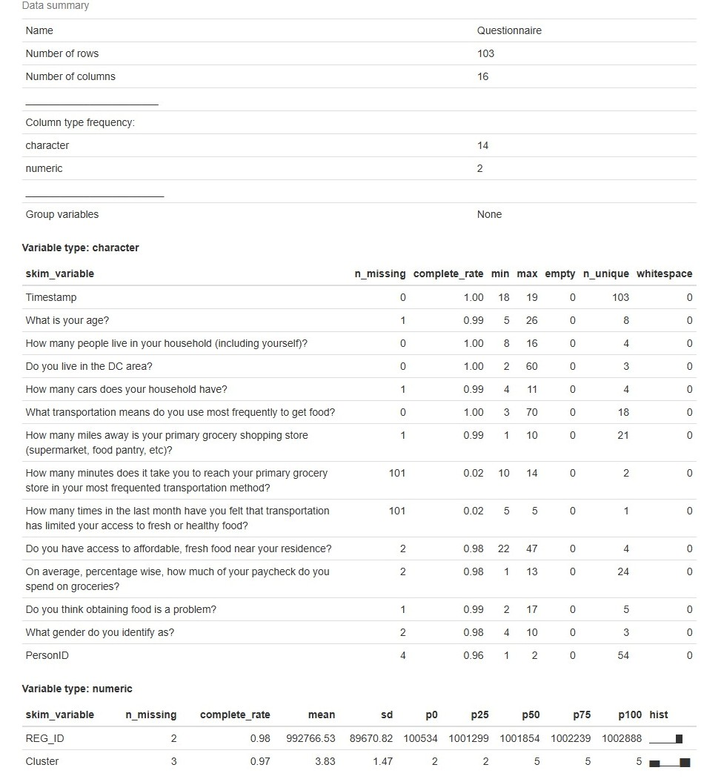

Data Cleaning Process

For Categorical Variables
- Text Standardization:
Responses to questions like access to fresh food were standardized for consistency. For example, "Yes, I’ve many options" was rephrased as "Yes, many options," ensuring uniformity across similar responses. This aids in reducing variability in categorical labels due to text differences, making data analysis more reliable.
- Binary Encoding:
Questions with yes/no answers, such as whether obtaining food is a problem, were encoded into binary variables (e.g., 1 for "yes" and 0 for "no"). This conversion simplifies statistical modeling, especially for logistic regression,
- Ordinal Encoding:
Age groups were converted into ordinal numeric values (e.g., "Under 18" as 1, “18-24" as 2). This encoding respects the natural order of categories and enables the use of these variables in regression models where ordinal relationships are important.
- Expanding Multiple-Choice Responses:
For transportation methods, responses were expanded into multiple binary columns. Each transportation means became a binary feature, indicating whether it was used. This transformation provides greater analytical flexibility by allowing simultaneous modeling of multiple attributes.
For Quantitative Variables
1. Parsing Numerical Values:
Textual responses indicating quantities, such as household size or miles to grocery stores, were converted into numeric formats. Examples include extracting numerical values from strings like "5 or more people" or "3-4 people” and assigning representative values (e.g., 5 or 3.5, respectively).

- Percentage Extraction:
Responses to questions like the percentage of income spent on groceries were cleaned by removing non-numeric characters and converting them into numeric percentages, facilitating arithmetic and statistical operations.
- Handling Missing Data:
Rows containing missing values (NA) were removed. While effective for creating a complete dataset, this step must be balanced against the risk of losing valuable data, suggesting the importance of assessing the proportion and impact of missingness.
- Creating New Variables:
Where necessary, new variables were derived by recording or transforming existing responses, aligning the dataset with the needs of subsequent statistical models, such as logistic regression.

After handling missingness, we were left with 91 observations. Later, the actual regression was reduced to 83 when “prefer not to say” responses from the research question and “non-binary” gender responses were removed due to too low a count for meaningful interpretation.
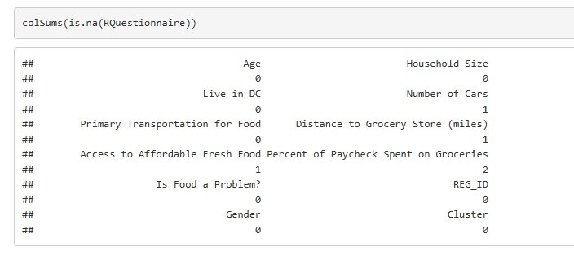
Missingness after data cleaning

Data exploration

Visualizations
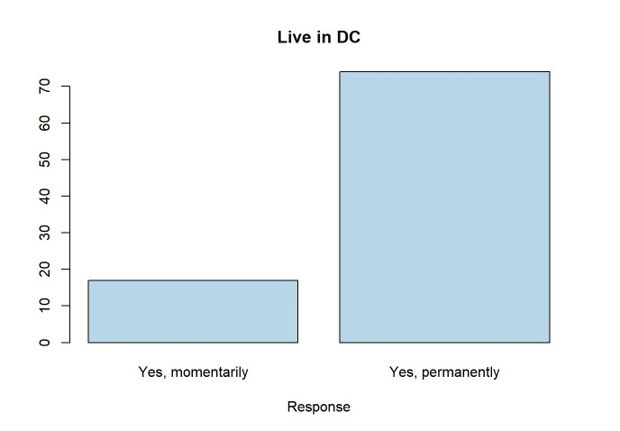 |  | 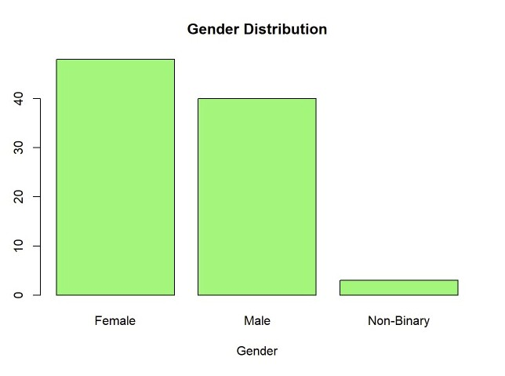
Contrary to our original concerns that non-DC college students would make up a large portion of our sample, the majority of respondents were permanent DC residents. This is beneficial for our analysis, as these individuals are more likely to have direct experience with food accessibility issues within the city. |  | For gender, female was the most common response. On the other hand, non-binary respondents represented only a very small portion of the sample. While this may reflect the broader population, the number of responses was too low for us to draw meaningful conclusions or make reliable comparisons involving this group.
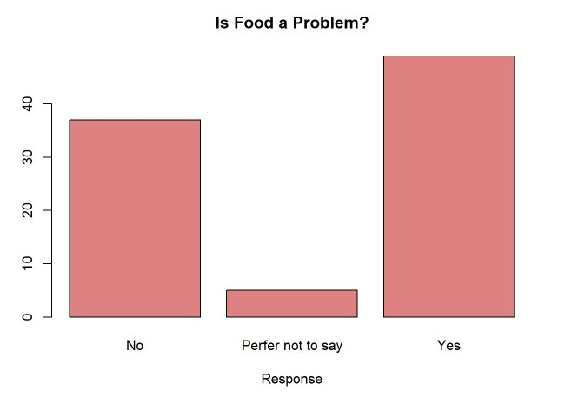 |  | 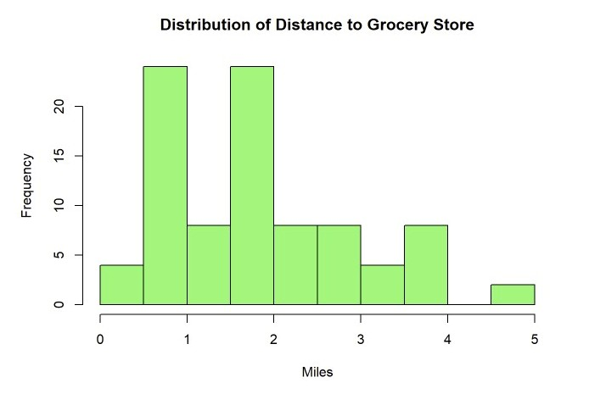
 | For our research question, a marginal majority of respondents believed obtaining food is an issue. While fewer than 10 preferred not to say, we gave this option to avoid nonresponse and potentially make use of what this could mean but ended up not making much use of it. Potential interpretations for it would be the assumption that social desirability bias did not allow them to answer truthfully, so they went for the safe option.
Our Distance to the grocery store’s histogram indicates the data would not be normal. This makes sense regarding how grocery stores are not built at random, and so the distance to them would not be quite continuous. Miles range from 0 to 5, with a majority having a grocery store near them within 1 to 2 miles.
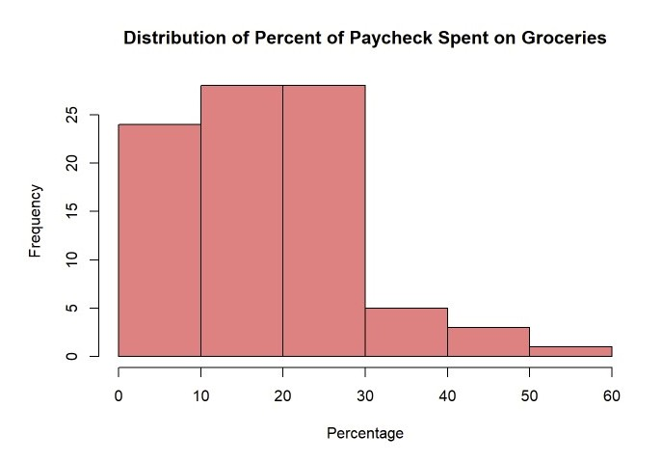 | 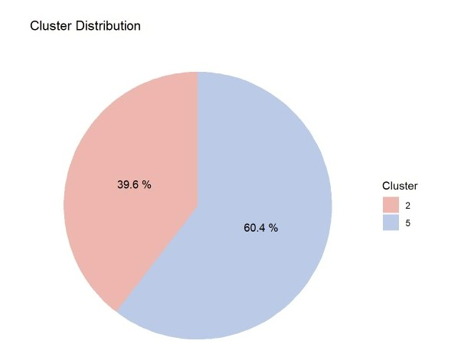
Many respondents seem to spend less than 30% of their paycheck on groceries, making the distribution positively skewed; more than 50% of them spent between 10% and 30%.
After data cleansing, our desired ratio for the clusters got a bit skewed, but not drastically so. 40%/60% for cluster 2 and cluster five as compared to the desired 35%/65%.

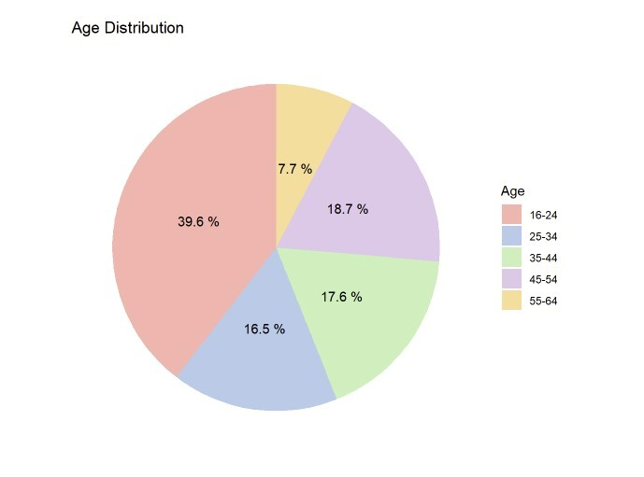 | 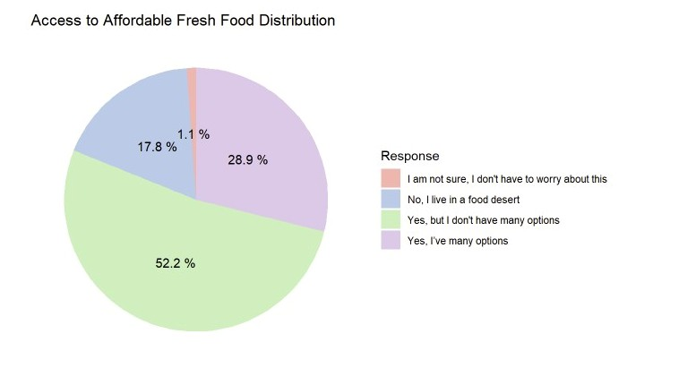
The age group 16-24 constitutes the largest proportion of the population, indicating that younger individuals make up a significant portion; this could skew our data. | The chart shows that most people (52.2%) have limited access to affordable fresh food, while 28.9% have many options. About 17.8% live in food deserts, and 1.1% are unsure or unaffected.
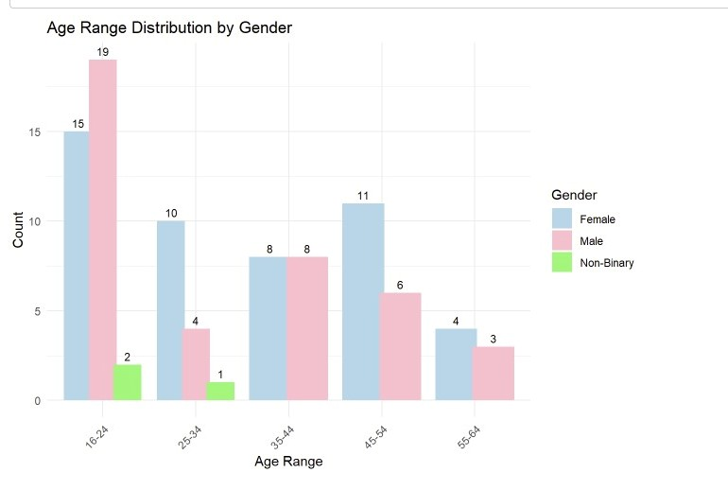 | 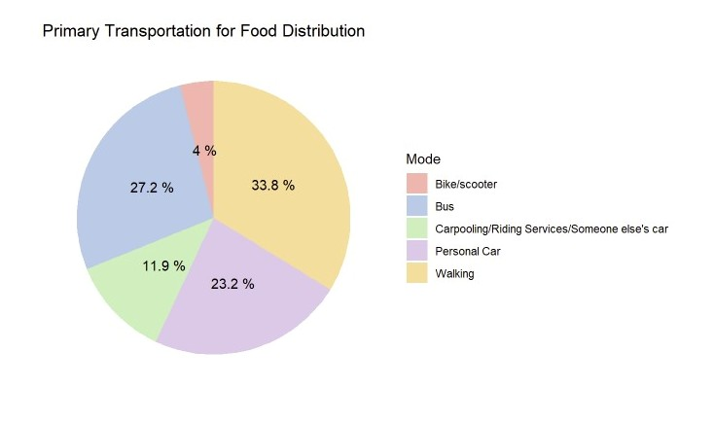
The chart shows the age range distribution by gender. The 16-24 age group has the highest representation, especially among females (19) and males (15), with fewer non-binary individuals (2), indicating that younger participants are more prevalent across genders. Other age groups show a declining count, with males leading in 45-54 and females leading in 54-64. | The chart shows the primary modes of transportation for food distribution, with Walking (33.8%) the most common, suggesting many people access food locally and indicating proximity to food sources.

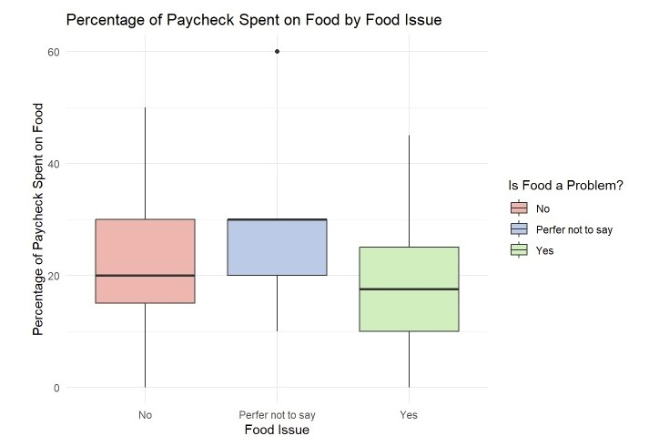 | 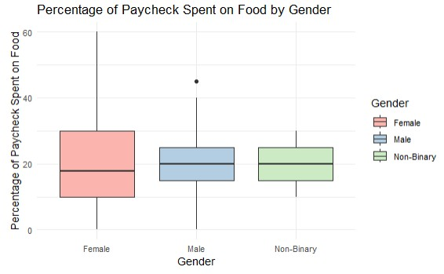
The chart compares the percentage of paychecks spent on food across respondents who perceive food as a problem, those who don’t, and those who prefer not to say. Respondents who identify food as a problem tend to spend a higher percentage of their paychecks on food, while those who don’t spend slightly less. | The chart shows the percentage of paychecks spent on food by gender. Females have the highest variability in spending, while males and non-binary individuals show more consistent spending patterns.

Modeling and Analysis
We proceeded to create logistic regression models to predict whether individuals perceive obtaining food as a problem (`Do you think obtaining food is a problem? `) based on various demographic, socioeconomic, and transportation-related variables. The outcome variable is binary, with 1 indicating "yes" and 0 indicating "no."
The model results include coefficients for each predictor, standard errors, z-values, and p-values, as well as overall model statistics like null deviance, residual deviance, and the Akaike Information Criterion (AIC).

Logistic Model 1 With Most Variables
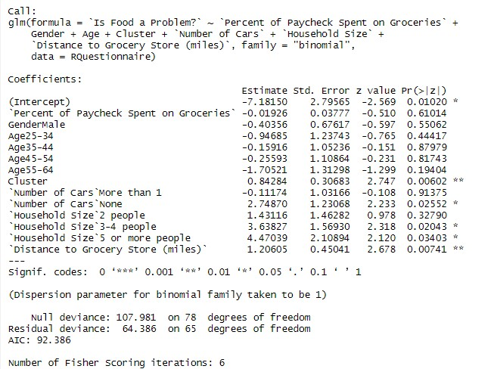
This first logistic regression model investigates the likelihood of food being a problem based on the predictors of the percentage of income spent on groceries, gender, age, cluster, number of cars, household size, and distance to the grocery store.
The analysis shows that several predictors have significant associations with food insecurity. Notably, Cluster (p=0.006) significantly predicts the outcome, with individuals in certain clusters more likely to report food as a problem.
Households with no cars (p=0.025), larger household sizes (3−4 people:
p=0.020; 5+ people: p=0.034), and longer distances to grocery stores (p=0.007) are also significantly more likely to experience food insecurity.
The model’s intercept (−7.18, p=0.010) is significant, indicating baseline differences in food insecurity likelihood when all predictors are at reference levels. Other variables, such as age, gender, and the percentage of income spent on groceries, did not have statistically significant effects (p>0.05).
The model's residual deviance (64.386) and AIC (92.386) indicate reasonable model fit, with 65 degrees of freedom.
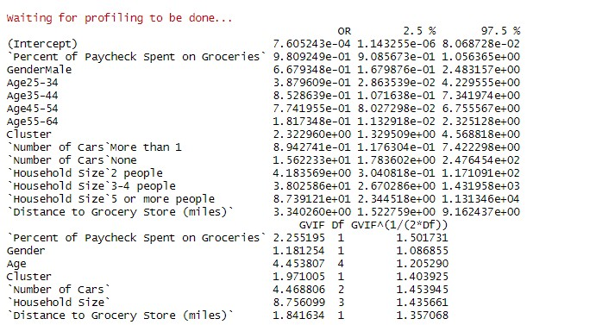
We also calculated the odds ratio for the model. Based on the results of the odds ratio test, we find some of the specifics of our model. We found that for our significant variable, individuals in specific clusters are over 2.3 times more likely to experience food insecurity (OR=2.32, 95% CI: 1.33–4.57). Transportation emerged as a key determinant; households without cars are over 15 times more likely to face food insecurity (OR=15.62, 95% CI: 1.78–247.65). Larger households also exhibit higher vulnerability, with those containing 3–4 members being 38 times more likely (OR=38.03, 95% CI: 2.67–1431.96) and those with 5 or more members showing an 87-fold increase (OR=87.39, 95% CI: 2.34–11,313.46). Additionally, a one-mile increase in distance to the grocery store raises the odds of food insecurity by over 3-fold (OR=3.34, 95% CI: 1.52–9.16). The variance inflation factors (VIFs) were within acceptable parameters for all predictors, indicating minimal or no multicollinearity.
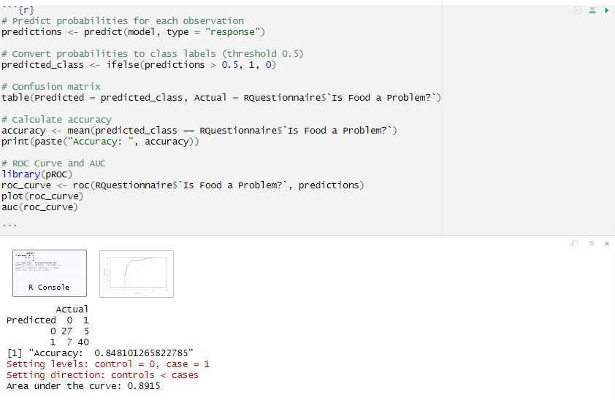
Finally, we predicted the accuracy of our model and graphed it. As shown, the confusion matrix indicates that the model correctly predicted 27 instances of "No" (true negatives) and 40 instances of "Yes" (true positives), with 5 false negatives and 7 false positives. This resulted in an accuracy of 84.81%, demonstrating strong classification performance.
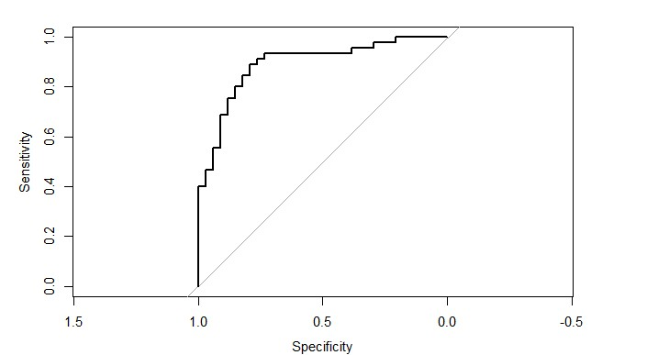
Similarly, our Receiver Operating Characteristic (ROC) Curve highlights the model's ability to distinguish between classes across different thresholds. The Area Under the Curve (AUC) is 0.8915, indicating excellent discriminatory power. We could say that our model identifies individuals at risk of food insecurity, making it a valuable tool for targeted interventions.
We had tried to reduce the model by removing non-significant variables, but the result was that not only did the variable’s odds ratio impact decrease, but our predictive accuracy was reduced. So, we stayed complacent with this model for the type being.

Conclusion

Summary
This study explores food insecurity in Washington, DC, focusing on barriers such as cost, transportation, and proximity to grocery stores. Using a survey targeting individuals aged 16 and older, questions addressed demographics, transportation, and household dynamics. Two income-based clusters, one above and one below the median income, were defined, with bus stops within these clusters serving as sampling locations to capture diverse socio-economic perspectives.
Data collection yielded 103 responses, though 27 were excluded due to missing data. The cleaning process involved standardizing categorical responses, encoding variables, and preparing numeric data for analysis. Logistic regression was employed to identify factors influencing perceptions of food accessibility challenges.
Key findings reveal that grocery store proximity significantly impacts food access perceptions, with greater distances increasing the likelihood of challenges. Household size also emerged as a significant factor, suggesting logistical challenges in larger households. Access to affordable, fresh food significantly reduces perceived barriers, while car ownership eases access issues. However, some expected predictors, such as gender and transportation modes, were not statistically significant, and variables like “riding services” were excluded due to sparse data or multicollinearity.
Our analysis highlights that food insecurity in DC is closely linked to factors such as household size, income, transportation access, and the distance to grocery stores. The logistic regression model demonstrates that individuals in lower-income clusters, those without cars, and those living further from grocery stores are at a higher risk of food insecurity. The model's high accuracy and AUC suggest it is a reliable tool for identifying at-risk populations and could be used to inform targeted interventions by policymakers.
While the survey methodology faced challenges such as low foot traffic and weather constraints, the findings provide valuable insights into the key determinants of food insecurity in the D.C. area. Further research could refine the model by incorporating additional factors and expanding the sample size to enhance its predictive power.
Although the study was limited by sample size, weather conditions during data collection, and the overrepresentation of younger respondents, it still provides useful insight into factors that may contribute to food-access challenges in DC. Future research with larger samples and additional explanatory variables could further improve understanding of how transportation, affordability, and neighborhood characteristics interact to influence food insecurity.
More broadly, this project demonstrates that food insecurity is influenced by more than income alone. Transportation access, household characteristics, and geographic proximity to grocery stores all appear to shape how individuals experience food access. Although our study was limited in scope, it highlights the value of combining survey research, geographic analysis, and statistical modeling to better understand complex public health issues.

Recommendations
- Expand Sampling: Broaden the sample size and recruit participants from additional clusters to capture diverse socioeconomic perspectives. Prioritize outreach to underrepresented groups to improve the study's generalizability.
- Enhance Survey Design: Conduct pre-tests to identify unclear questions and refine wording (e.g., "affordable" or "fresh"). Add questions to capture environmental factors, such as seasonal food availability, local grocery prices, and food quality, for a more comprehensive analysis.
- Implement Longitudinal Surveys: Introduce follow-up data collection to track trends in food insecurity over time. This approach will also help evaluate the effectiveness of policy interventions.
- Mitigate Missing Data: Use advanced techniques like multiple imputations to minimize information loss from incomplete responses, preserving dataset integrity and analytical power.
- Adopt Advanced Statistical Models: Apply penalized regression methods like LASSO to manage multicollinearity and identify the most impactful predictors. Investigate interactions between variables, such as how transportation modes interact with grocery store distance.
- Develop Actionable Policies: Utilize insights to propose targeted solutions, such as subsidies for public transportation, community-driven grocery delivery services, or incentives to attract grocery stores to underserved neighborhoods. Focus on practical measures to alleviate identified barriers.
- By refining these areas, the study can provide deeper insights into food insecurity and offer evidence-based strategies for addressing this critical issue.

Future Directions
- Expand Dataset: Increase the sample size by targeting additional clusters and engaging diverse populations, including underserved communities.
This will enhance representativeness and statistical reliability.
- Refine Survey Design: Pre-test and revise the survey to eliminate ambiguities, such as clarifying terms like "affordable" or "fresh." Add options like "prefer not to say" to reduce missing data and response bias.
- Incorporate Longitudinal Data: Conduct follow-up surveys to monitor changes in food insecurity over time and evaluate the impact of interventions or policy changes.
- Integrate Environmental Contexts: Expand the dataset to include variables like food prices, geographic access, and seasonal availability. Use GIS data to analyze the spatial distribution of grocery stores and food deserts.
- Apply Advanced Modeling Techniques: Address multicollinearity using methods like Ridge or LASSO regression. Explore interactions between key factors, such as how transportation access influences the impact of grocery store proximity.
- Validate Self-Reported Data: Cross-reference survey responses with objective data sources, such as grocery receipts, GIS-based distance measures, or external food availability indices.
- Expand Research Scope: Study broader outcomes, such as dietary quality, nutritional health, and economic impacts of food insecurity, to provide a more holistic understanding of the issue.
- Develop Practical Policy Solutions: Leverage findings to propose targeted interventions, including food subsidies, public transportation support, and incentives for grocery stores to open in underserved areas. Tailor recommendations to address both immediate and systemic challenges.

References
"DC Metro Bus Routes." Open Data DC, Government of the District of Columbia, https://opendata.dc.gov/datasets/e85b5321a5a84ff9af56fd614dab81b3_53/explo re
"DC Neighborhoods." Open Data DC, Government of the District of Columbia, https://opendata.dc.gov/datasets/a53c0f02804a484b87027ce3ef3ff38b_41/about
.

